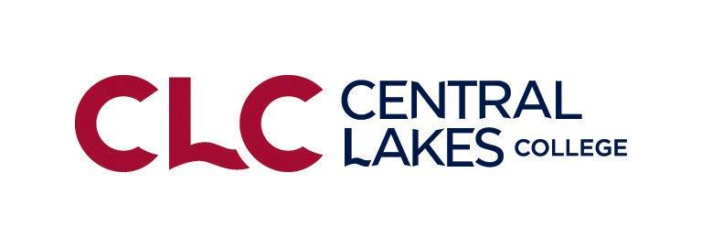
Central Lakes College FBM Suggested Balance Sheet Prices
January 1, 2021 Suggested Balance Sheet Prices for Non-priced Commodities (2020 Analysis Year End)
Crop Suggested Price
Wheat, Spring $5.50/bushel $5.25 - $5.75
Wheat, Winter $5.20/bushel
Wheat, Durum $6.00/bushel
Barley, Feed $2.50/bushel
Barley, Malting $4.75/bushel (most contracted bushels in 2020 are at $4.75)
Oats $2.30/bushel
Rye $3.75/bushel
Soybeans $11.00/bushel Range $10.50-11.50
Corn $3.75/bushel Range $3.50-4.00
Flax $10.20/bushel
Canola $19.70/cwt
Sunflowers, Oil $18.75/cwt
Sunflowers, Confectionary $24.00/cwt
Beans, Navy $27.00/cwt
Beans, Pinto $27.00/cwt
Beans, Garbonzo $23.00/cwt
Beans, Black Turtles $29.00/cwt
Beans, Dark Red Kidney $34-39.00/cwt
Grass Seed, Perennial Rye $55-60.00 per CWT.
Grass Seed, Kentucky Blue Grass $150.00 per CWT.
Grass Seed, Tall Fescue $ 50.00 per CWT.
Potatoes $10-12.00 per CWT.
Potatoes, Seed $14.00 per CWT.
Alfalfa Hay $135.00 -$160.00 for up to 150 RFV add $1.00 for each point RFV over 150 RFV
Mixed hay (Alfalfa/Grass) $ 95.00 Range $75.00 - $110.00
Grass or Small Grain Hay $ 75.00 Range $55.00- $100.00
Peas, Field $.10/lb

Forgage and Feed Suggested Prices Per Ton Values
Alfalfa Hay $150.00 -$200.00 for up to 150 RFV add $1.20 for each point RFV over 150 RFV
Mixed hay (Alfalfa/Grass) $ 95.00 Range $85.00 - $105.00
Grass or Small Grain Hay $ 75.00 Range $65.00- $85.00
Oatlage/Other/Peas Convert to dry mixed hay
Small Grain/Sorghum Silage (straight) Convert to dry grass hay or silage
Corn Silage $35.00
Corn Stalk Bales $30.00 per bale ($30-35 per large round bale)
Corn Snaplage $100.00 (90-110) or convert to corn
Corn $3.50/ bushel
Oats $2.15/ bushel
Straw (Large Bales) $ 90.00/ ton Small square bales $125-140/Ton
Pasture, Well Managed $35/AUM($30-$40)
Pasture, Normal Managed $20/AUM ($15-$25)
Pasture Cow/Calf Pair $25/ month on Pasture
Feeder Steers @ 450lbs $180.00 per CWT Heifers @450lbs $152.00 per CWT
Feeder Steers @ 550lbs $155.00 per CWT Heifers @550lbs $143.00 per CWT
Feeder Steers @ 770lbs $135.00 per CWT Heifers @770lbs $125.00 per CWT
Feeder Steers @ 900lbs $121.00 per CWT Heifers @900lbs $115.00 per CWT
Finished Cattle @ 1350lbs $98.00 per CWT
Finished Cattle, Dairy @ 1500lbs $85.00 per CWT
Dairy Bull, Calves $80 per calf
Dairy, Heifer, Calves $60 per calf
Lambs, Slaughter Weight (150-200) $ 150 per CWT $140 - $160/CWT
Lambs, Feeder Weight (70-80) $ 175 per CWT
Weaner, Pigs $ 15 per head
Feeder Pigs, 40 pound ave. $ 20 per Head
Dairy Cows $1200 per head average (1100-1400) (new herd reference)
Dairy Heifers $1400 per head average (1250-1500)
Beef Cows $1000 per head average (900-1100) (new herd reference)
Beef Heifers $1250 per head average (1050-1400)
Hybrid Beef/dairy List as “beef” and value between both beef & dairy
Dairy Goat $350

Organic Production Prices
Organic Corn $6.20
Organic Silage $70.00 - $80.00
Organic Alfalfa Hay $150.00 - $180.00
Organic Mixed Hay $110.00 - $140.00
Organic Soybeans $18.00
Organic Buckwheat $.32/lb $15.36/bu.
Organic Oats $5.00 - $6.50
Organic Oatlage $45.00

